Web Development & HCI

Web Development with HTML & CSS

FC Barcelona Fan Club

[Student Name]

[Student ID]

Table of Content

Table of Contents

Site Content & Design 3

Website URL 3

Topic of the Website 3

Website Type & Wireframes 3

1. Homepage Wireframe 3

2. About Us page wireframe 4

3. News page wireframe 5

4. News entry page wireframe 6

5. Contact us page wireframe 7

Use of HTML5 8

CSS Explanation 9

Positioning 10

CSS Techniques 10

Page break-line technique 10

Main container technique 10

Body defaults technique 10

Google font technique 11

Structured CSS technique 11

Navigation Toggle technique for windows-based tablet 11

CSS Transition Technique 11

CSS Techniques References 12

Graphic & Other Media 12

Testing Website Responsiveness 13

Chrome 13

Firefox 16

Microsoft Edge 19

Validation 22

HTML Validation 22

CSS Validation 25

Copyright Permissions 26

# Site Content & Design

## Website URL

**URL:** [**http://mywebsite.com**](http://mywebsite.com)

## Topic of the Website

This website is about FC Barcelona club, and it has some of the club information such as history of the club, achievements, club members, and latest news.

## Website Type & Wireframes

This website has an elastic layout which changes based on the screen size, and it has 6 different media queries to cover all the screen sizes like wide screen, tablet and mobile.

Below are the specified screen sizes used:

* Full screen
* Screen resolution between 1166px and 826px
* Screen resolution with a max width of 825px
* Screen resolution with a max width of 760px
* Screen resolution with a max width of 625px
* Screen resolution with a max width of 425px

### 1. Homepage Wireframe

This is the homepage layout consist of key elements of the website structure showing a general idea of the website topic.

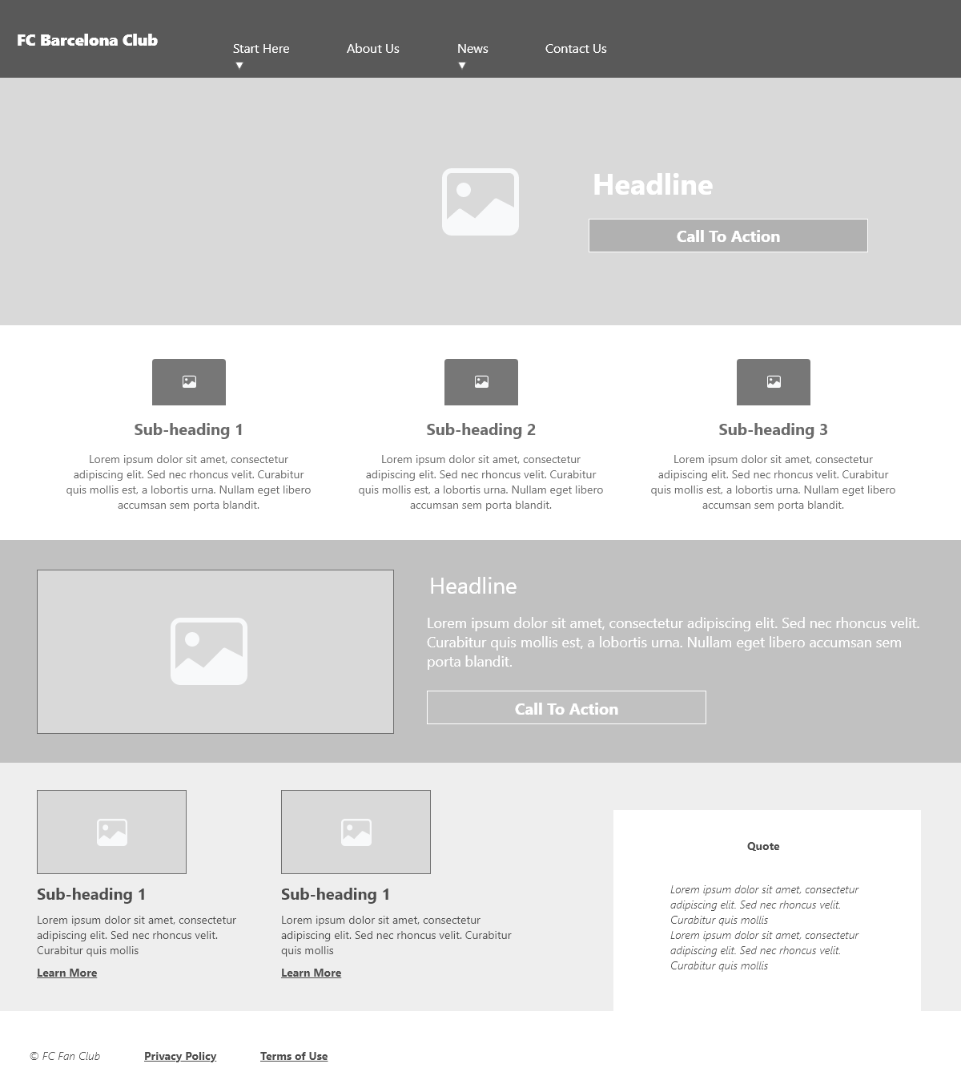

Figure 1 Homepage

### 2. About Us page wireframe

This page contains some info about the origin and history of the club with a picture of the players.

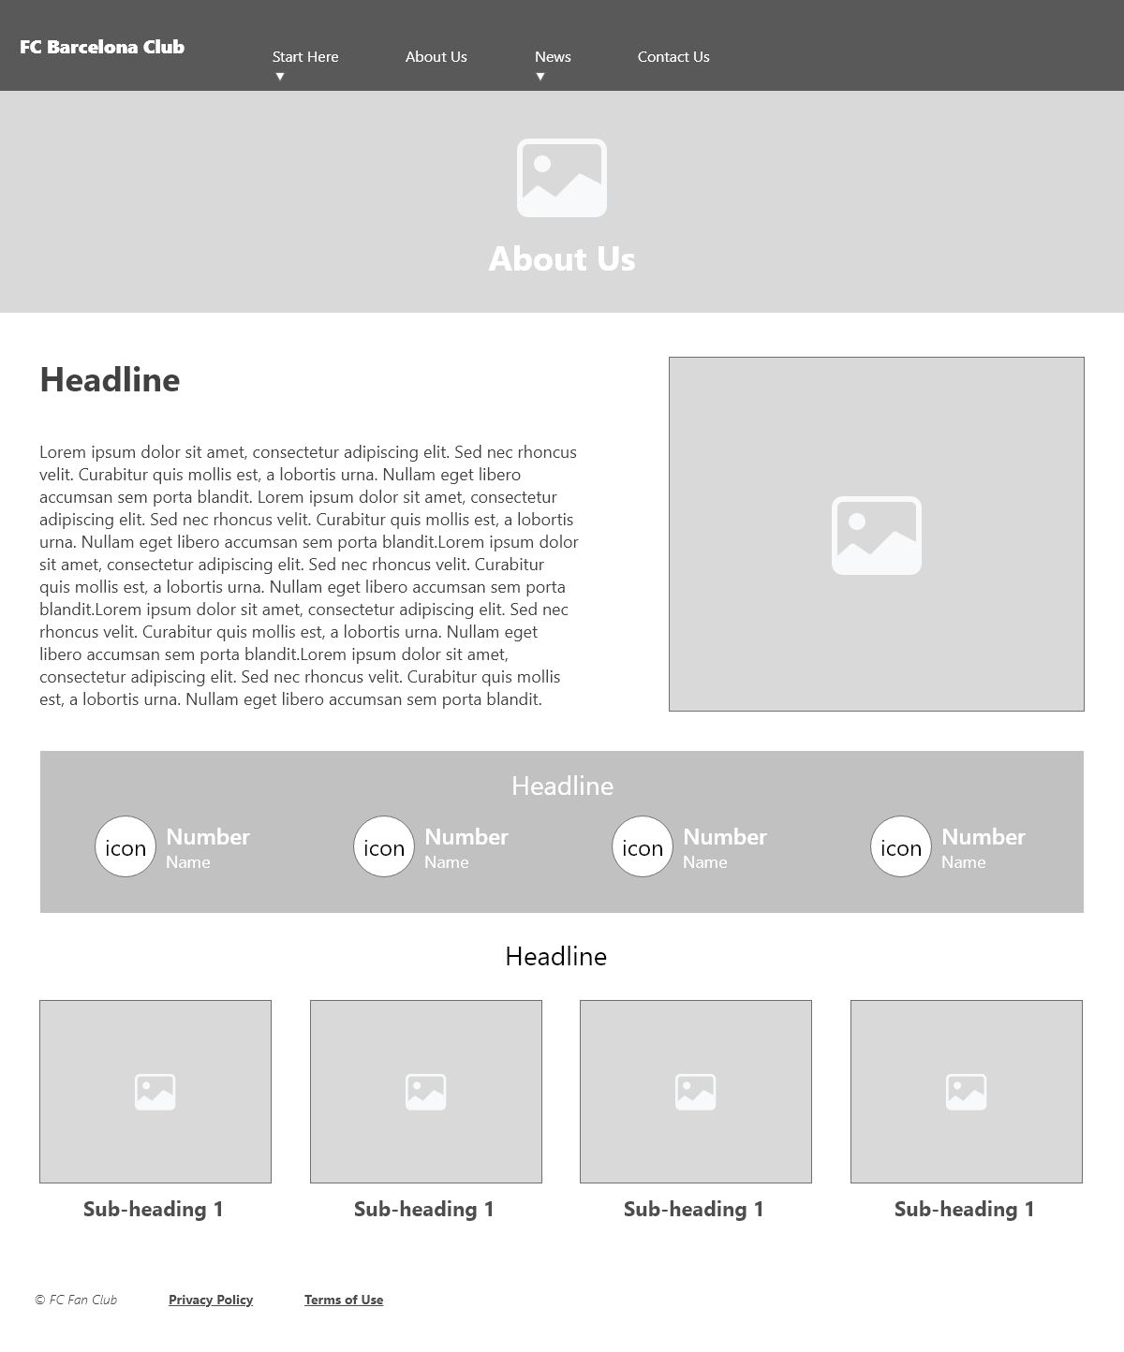

Figure 2 About Us page

### 3. News page wireframe

This page contains a list of the latest news about the club and its activities. It has a newsletter signup field as well.

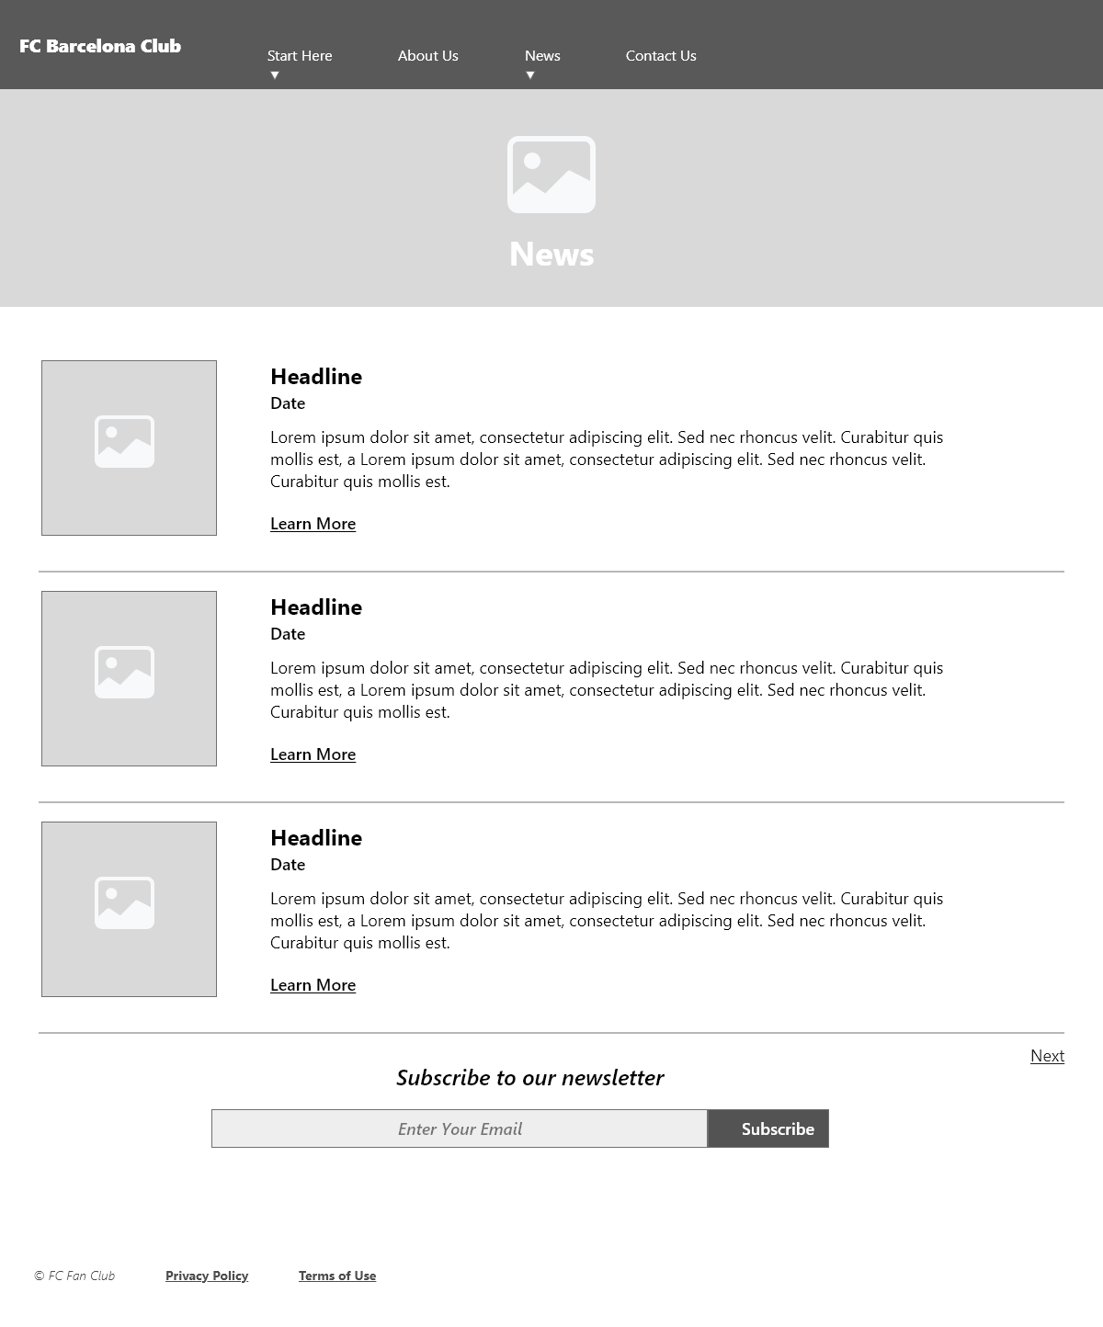

Figure 3 News page

### 4. News entry page wireframe

This page contains a news article with some media and a sidebar of related news.

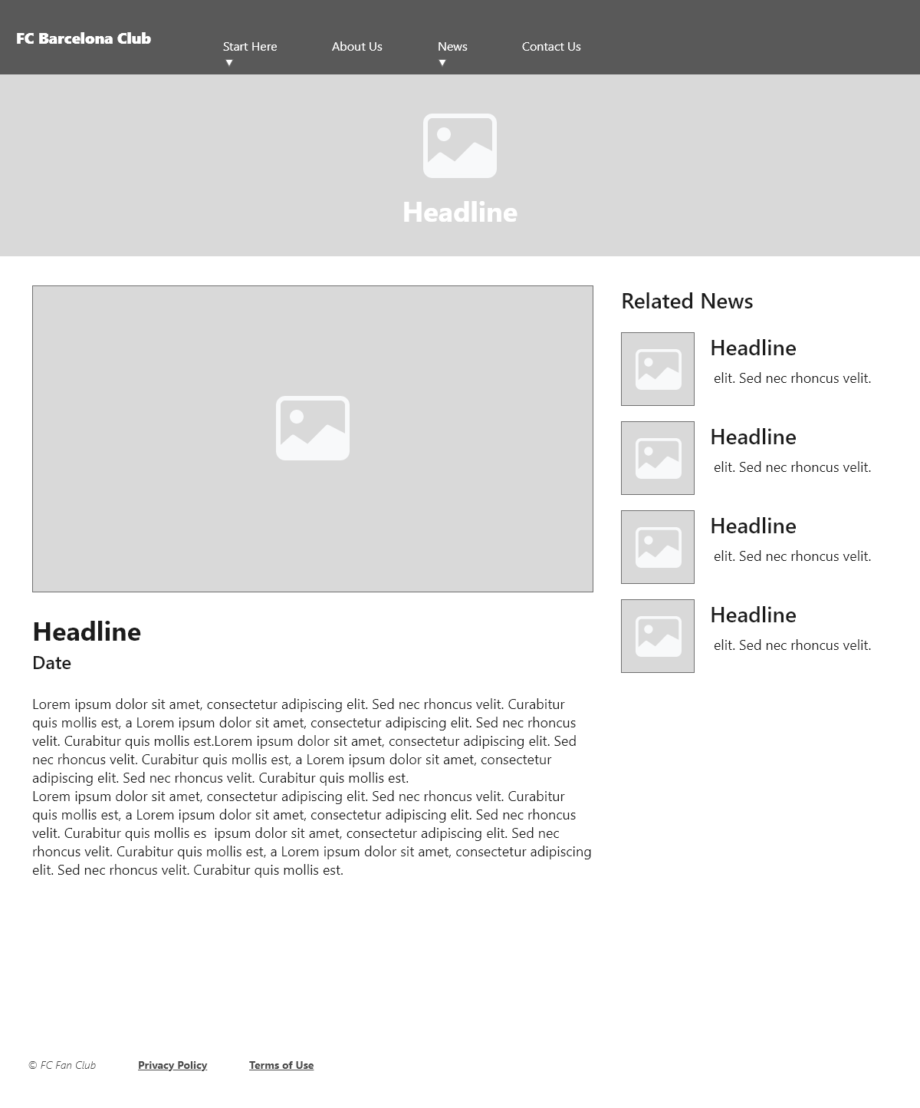

Figure 4 News article page

### 5. Contact us page wireframe

This page contains a news article with some media and a sidebar of related news.

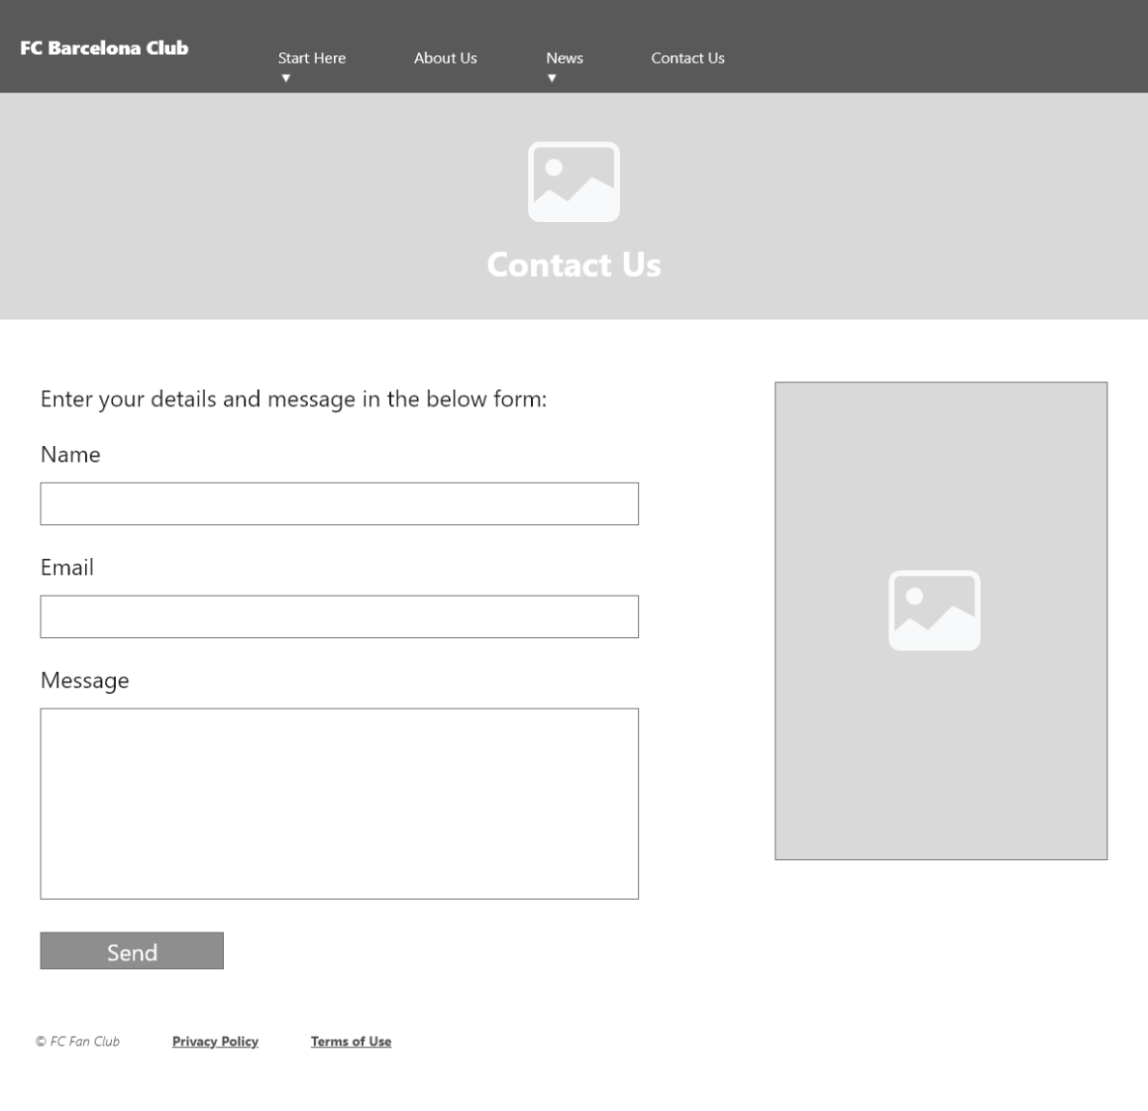

Figure 5 Contact us page

# Use of HTML5

Used essential HTML5 elements to create the web page’s structure and elements used are:

* Header
  + First element of the page which contains website logo and hero to show the main headline of the website with a call-to-action button.
* Section
  + Used to create the rows for different types of content that come after the header element.
  + Used sections for contents like news entries, atmosphere block, posts.
* Aside
  + Used to create columns within the section element to arrange the content as required to group related elements together for better user experience.
  + Used to create a sidebar in the news post page to show a list of related news.
* Div
  + Used as a content holder within the section elements and aside element to have a simple way to target specific content using assigned CSS classes to the divs.
* Span
  + Used to target small pieces of text content for specific formatting and positioning.
* Footer
  + Used to add the copyright information.
  + Used to add a few links for the legal pages.
  + Used to add an attribution link for the website used for the icons as the icons are free but required attribution link to be available in the website for license use policy.

# CSS Explanation

Used CSS in a couple of external files linked to the web pages to style the HTML5 elements.

Below table shows the basic layout structured used on the website keeping in mind the main content which comes after the header element may vary for different pages based on content amount and structure.

**This table is a showing structure of the homepage:**

|  |
| --- |
| **Header** |
| **Section (main)** |
| **Section (atmosphere)** |
| **Section (featured content)** |
| **Nav (main menu) repositioned using css** |
| **Footer** |

Colored schema used in the website is taken from the club’s logo.



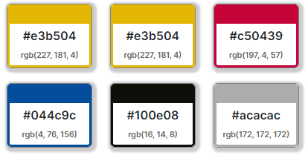

Figure 6 Color codes used

### Positioning

Used position property with the relative and absolute values to position some of the elements of the website to match the wireframes.

Used margins and padding to make container elements more eye catching as the images and text content don’t align to the edges.

Used classes instead of Ids for easy selector targeting as most of the elements aren’t unique enough to use the id attribute except for page container **#page**.

# CSS Techniques

Here are some of the CSS techniques used in the website:

## Page break-line technique

A common issue in CSS is that some of the HTML elements are not being stacked correctly in the web page layout so to fix such issue used the below code.

***section::after {content: "";display: block; clear: both;}***

## Main container technique

Created a main container for the website to establish the width of the whole layout using the below code.

***#page {max-width: 1200px;margin: 0 auto;position: relative;background-color: #FFF;}***

## Body defaults technique

Established the default values for the main properties of the website in the body selector. A zero value used for padding and margin in body as default.

***body {***

***font-family: 'Open Sans', sans-serif;***

***font-size: 16px;***

***font-weight: 300;***

***color: #555;***

***margin: 0;***

***padding: 0px;***

***left: auto;***

***background-image: url("../images/background.jpg");***

***background-size: cover;***

***}***

## Google font technique

Used a google font CSS code for the website to set the default font and added a local font as will as an alternative.

***@import url('https://fonts.googleapis.com/css2?family=Open+Sans:ital,wght@0,300;0,700;1,300;1,700&display=swap');***

## Structured CSS technique

Structured the CSS code to match the html elements meaning if the header code is used first then the CSS styling for the header will be used in parallel.

## Navigation Toggle technique for windows-based tablet

Used the attribute selector to fix the issue of toggling submenu items in the windows based tablet.

***nav a[aria-haspopup="true"]::after {***

***content: "";***

***display: block;***

***width: 0px;***

***height: 0px;***

***position: absolute;***

***top: 16px;***

***right: 15px;***

***border-top: 4px solid transparent;***

***border-bottom: 4px solid transparent;***

***border-left: 4px solid #FFF;***

***}***

## CSS Transition Technique

Used the transition to animate call-to-action button background.

***transition: background-color .5s;***

### CSS Techniques References

Below is a list of websites used as references of some of the techniques used in the website.

[ARIA Haspopup property - Level Access Web Labs](https://labs.levelaccess.com/index.php/ARIA_Haspopup_property)

[CSS Media Queries (w3schools.com)](https://www.w3schools.com/css/css3_mediaqueries.asp)

[CSS Transitions (w3schools.com)](https://www.w3schools.com/css/css3_transitions.asp)

[Browse Fonts - Google Fonts](https://fonts.google.com/)

[css float - What does the CSS rule "clear: both" do? - Stack Overflow](https://stackoverflow.com/questions/12871710/what-does-the-css-rule-clear-both-do)

# Graphic & Other Media

Below are the websites used for media assets.

* Google Images
  + All images downloaded are filtered by common creative license
* [Icons8](https://icons8.com/)
  + Used free icons from this website but it required attribution link to be added.
    - Added link in footer
* [Pixabay](https://pixabay.com/)
  + Free image library website (no attribution required)

# Testing Website Responsiveness

### Chrome

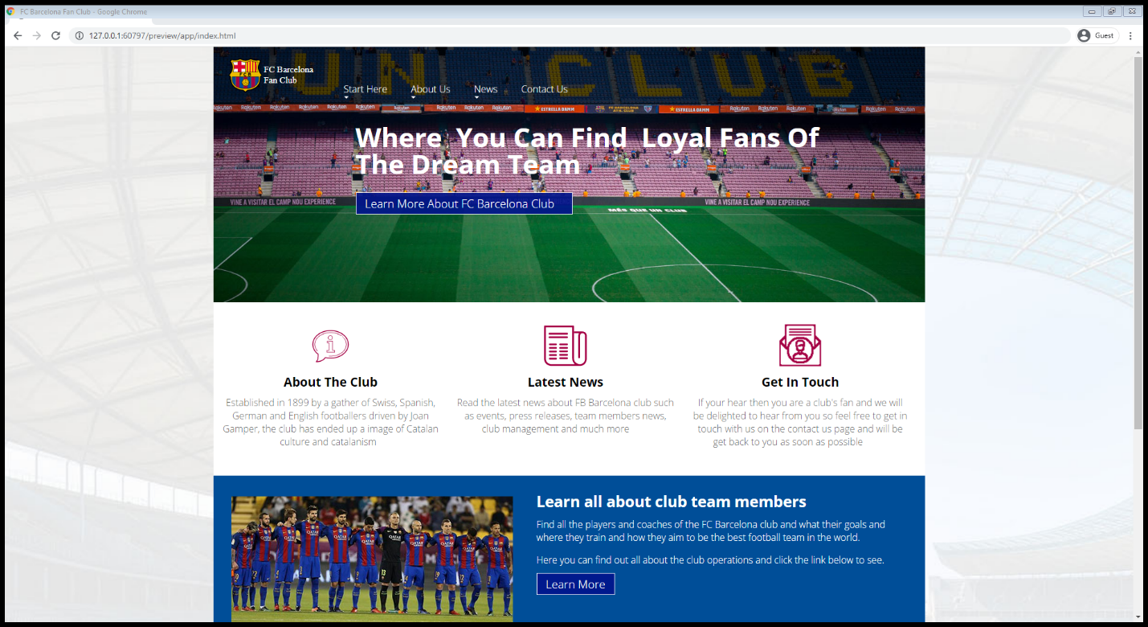

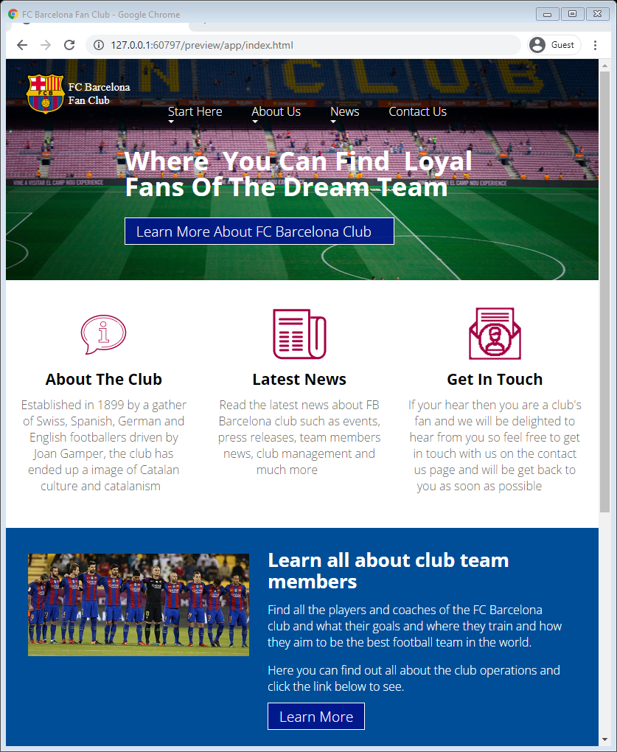

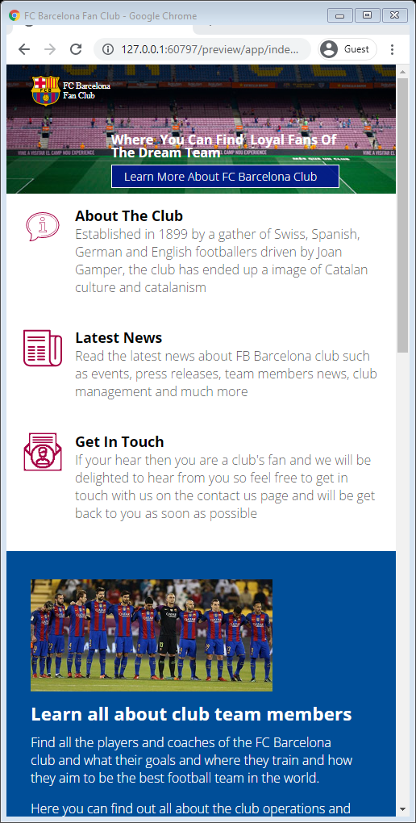

### Firefox

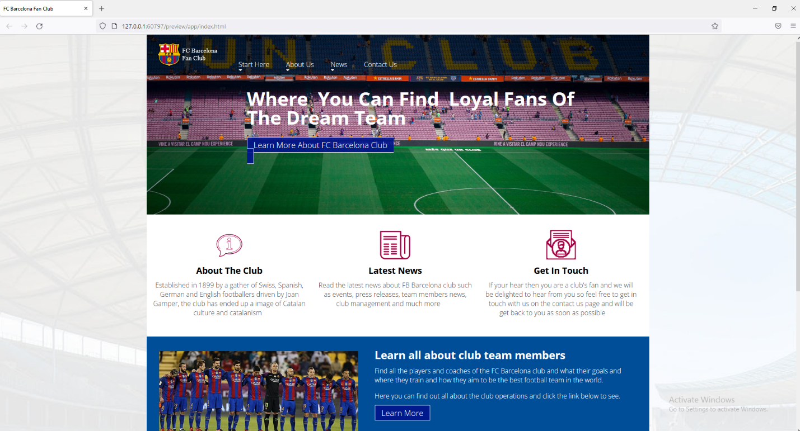

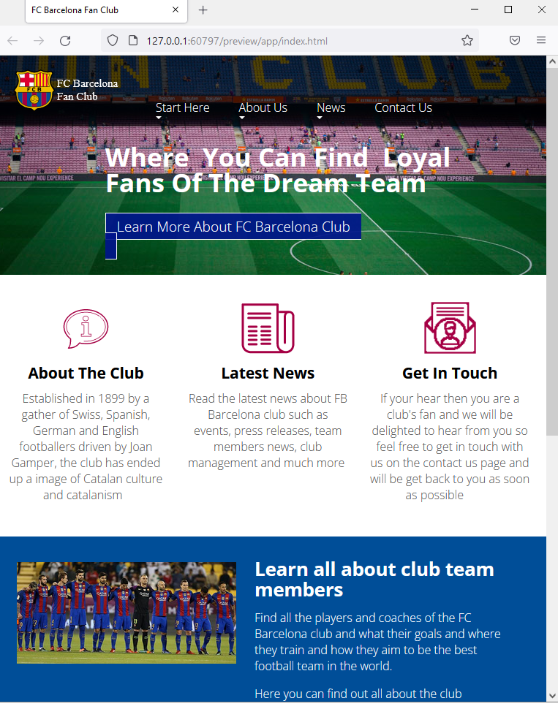

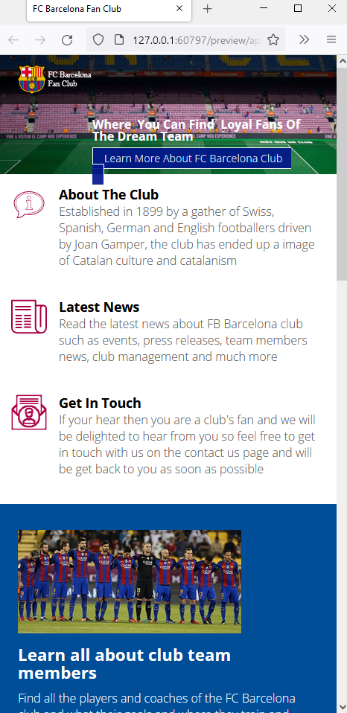

## Microsoft Edge

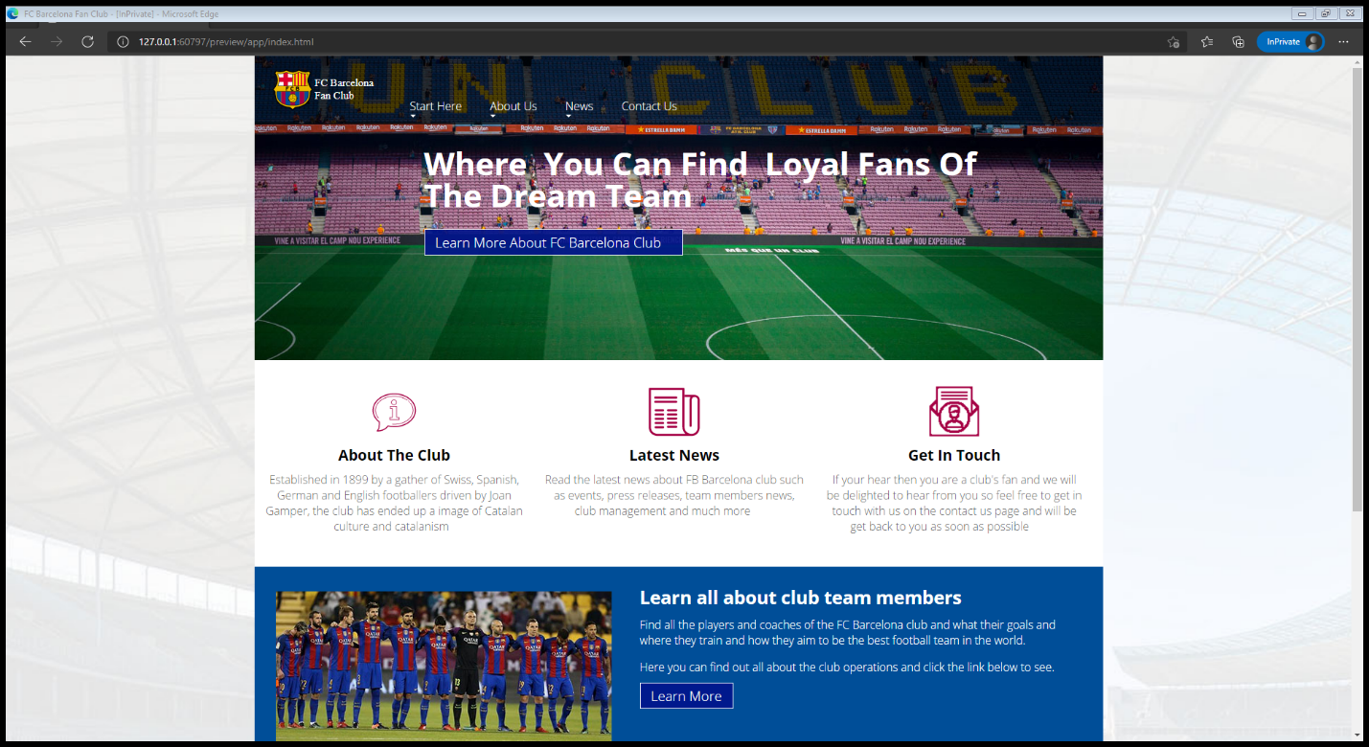

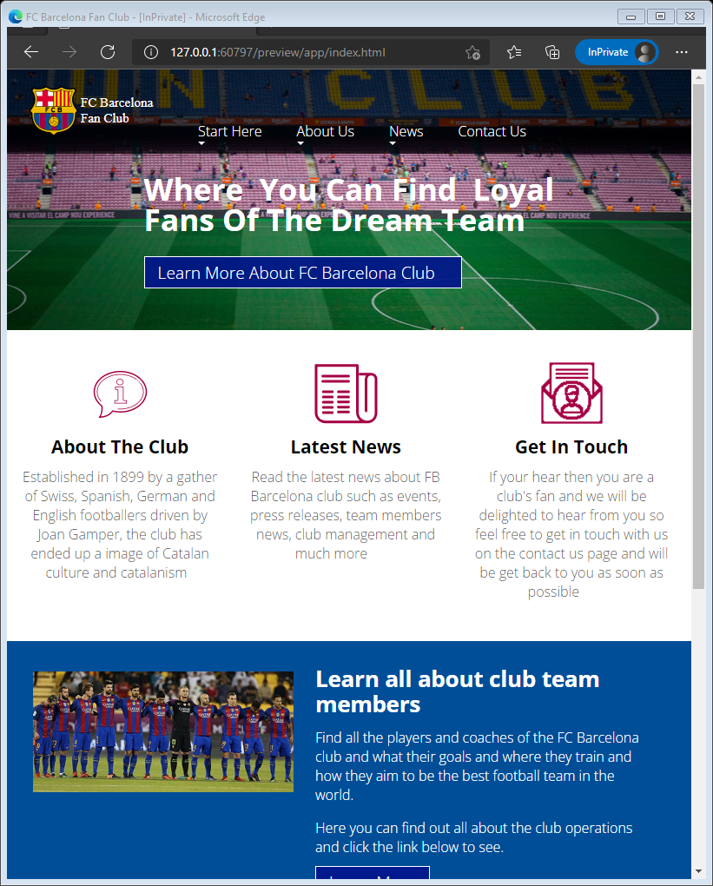

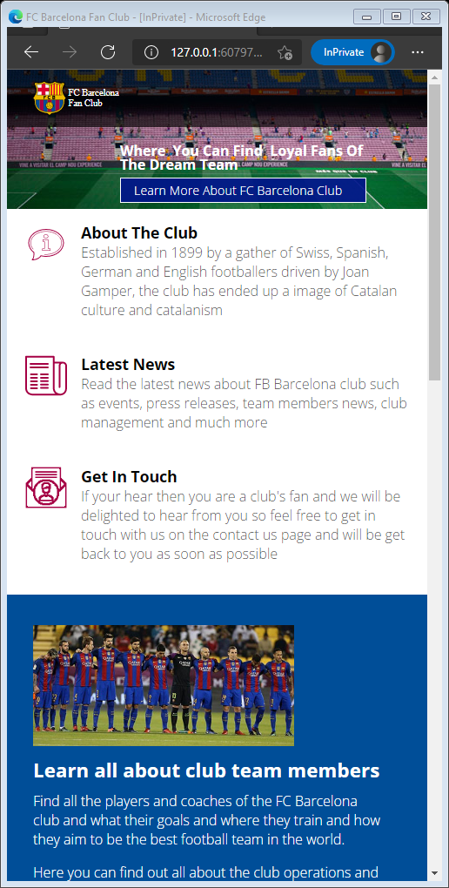

All pages render the same on all mentioned browsers.

# Validation

### HTML Validation

Homepage (passed) but got suggestion to use more heading elements as there is no need to use more than three heading type on the website, h1,h2 and h3.

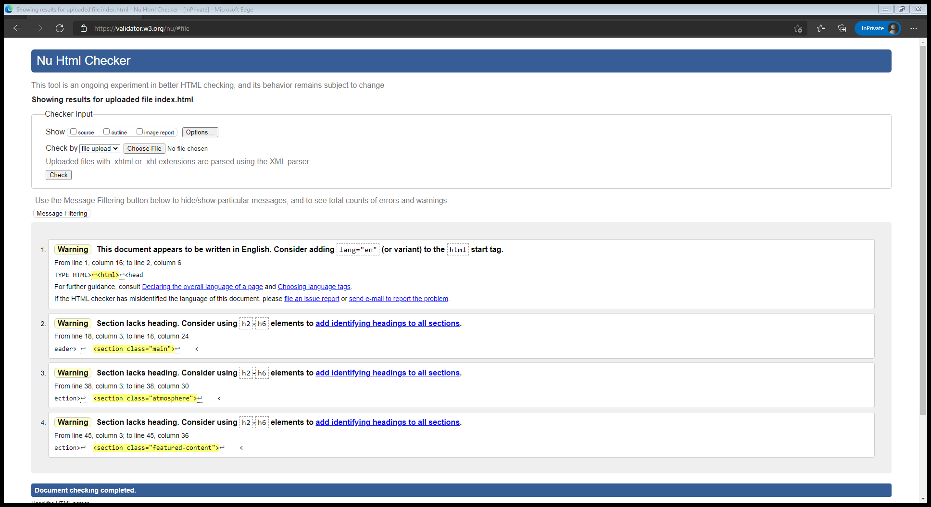

Figure 7 Homepage

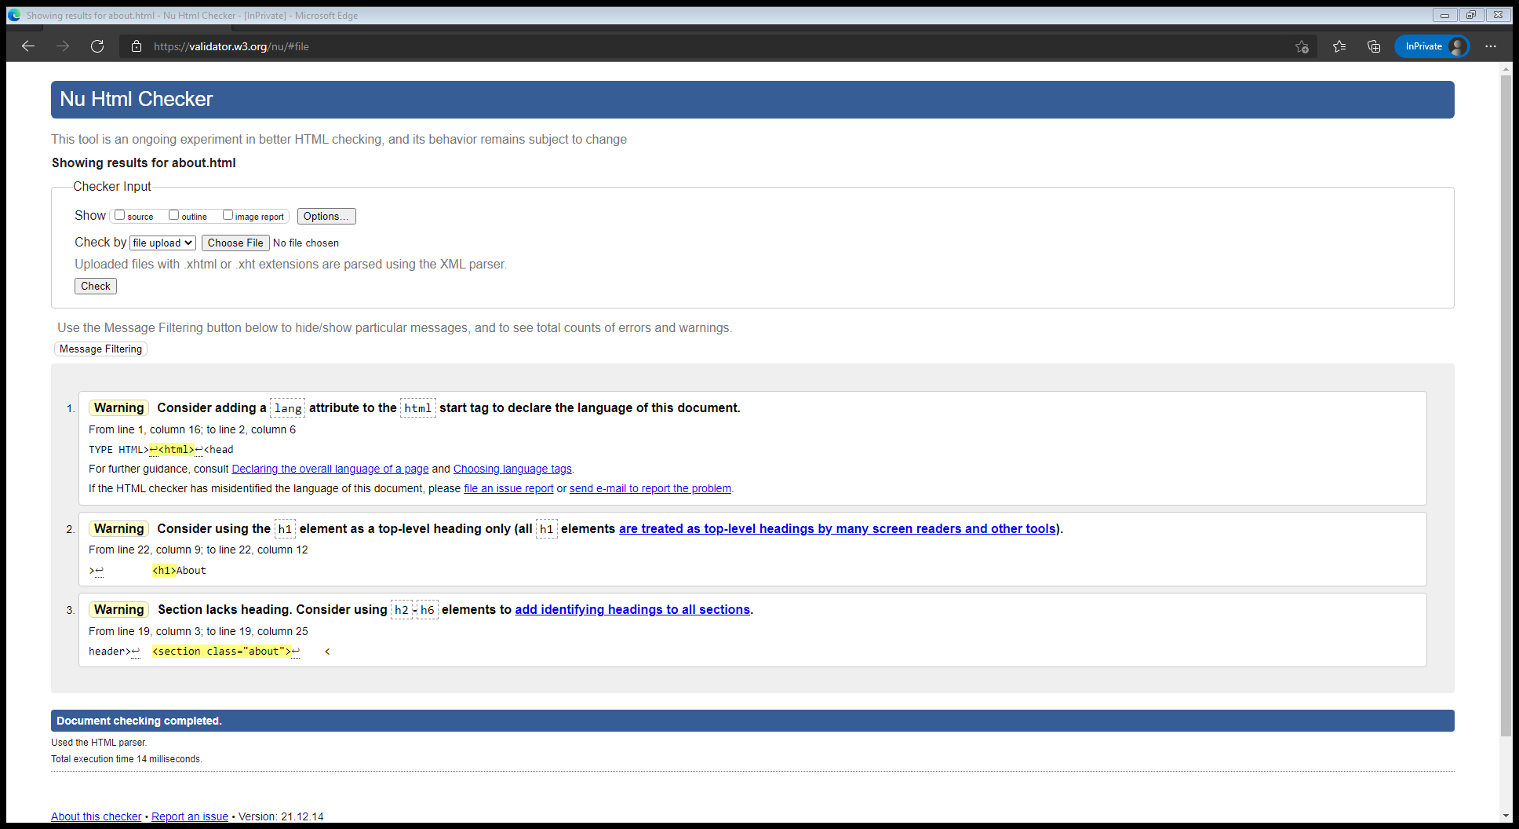

Figure 8 About us

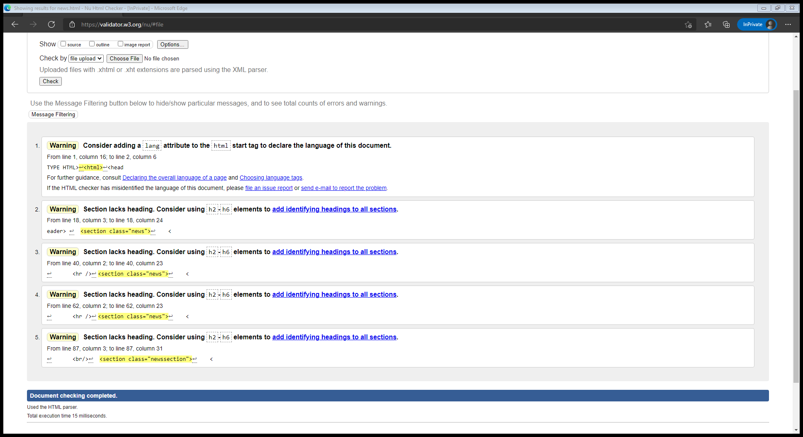

Figure 9News

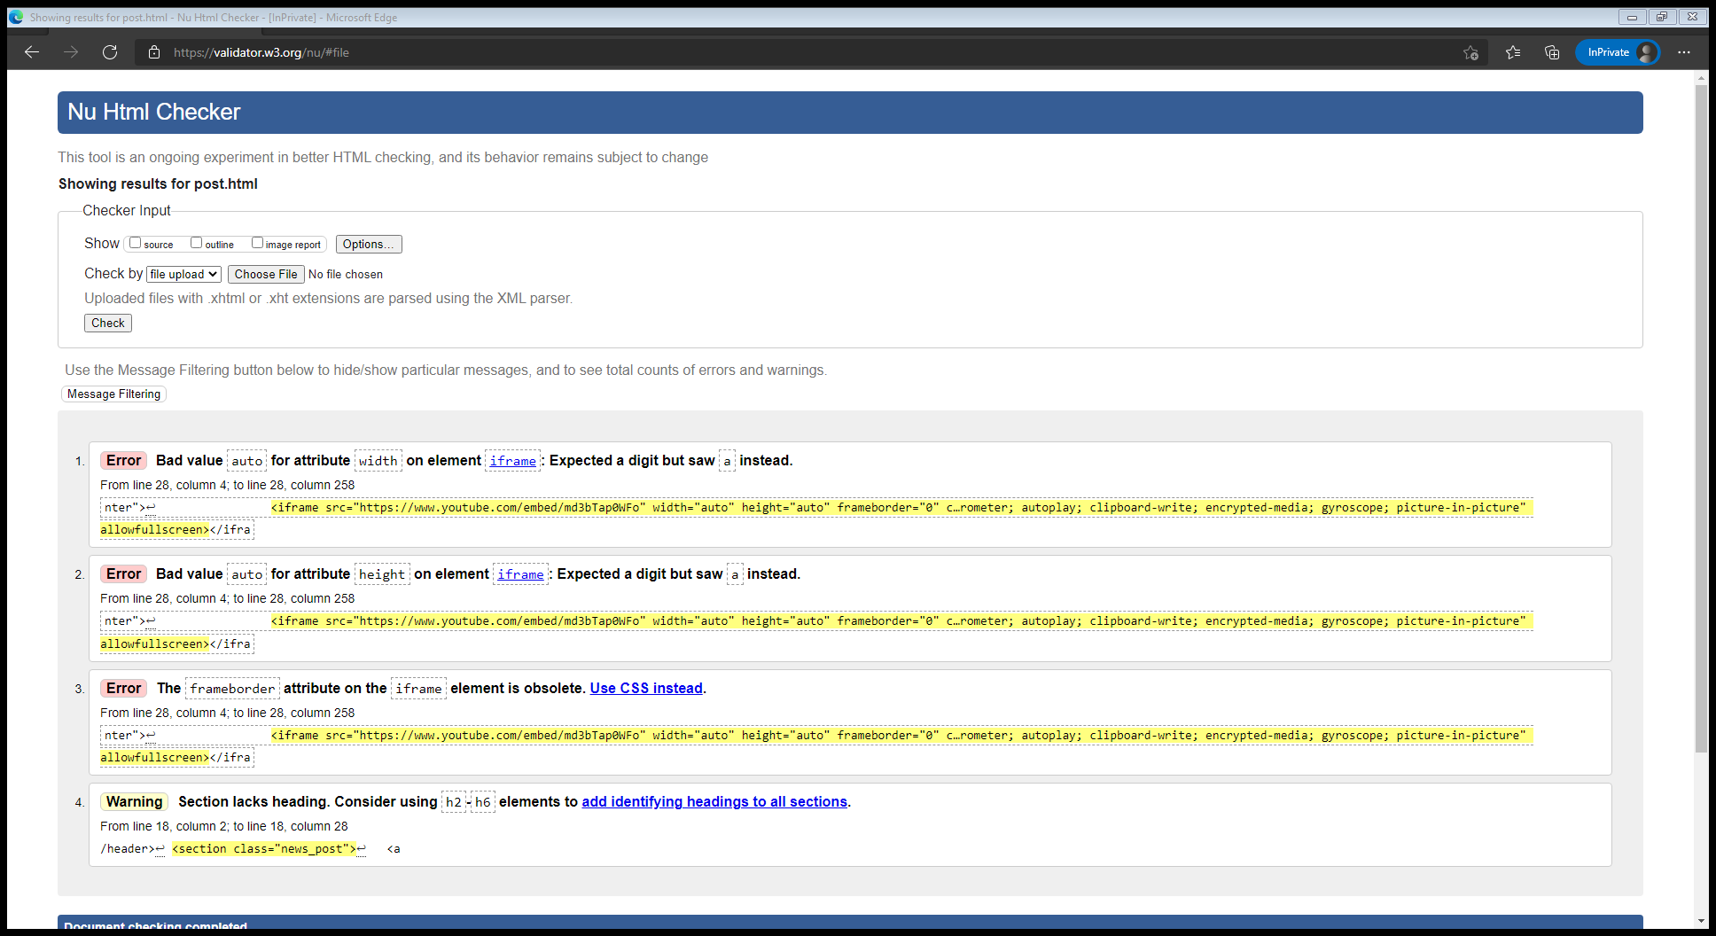

Figure 10 News Post

Fixed the html lang warning.

Other warnings are from the YouTube embed which is not a part of the website original code.

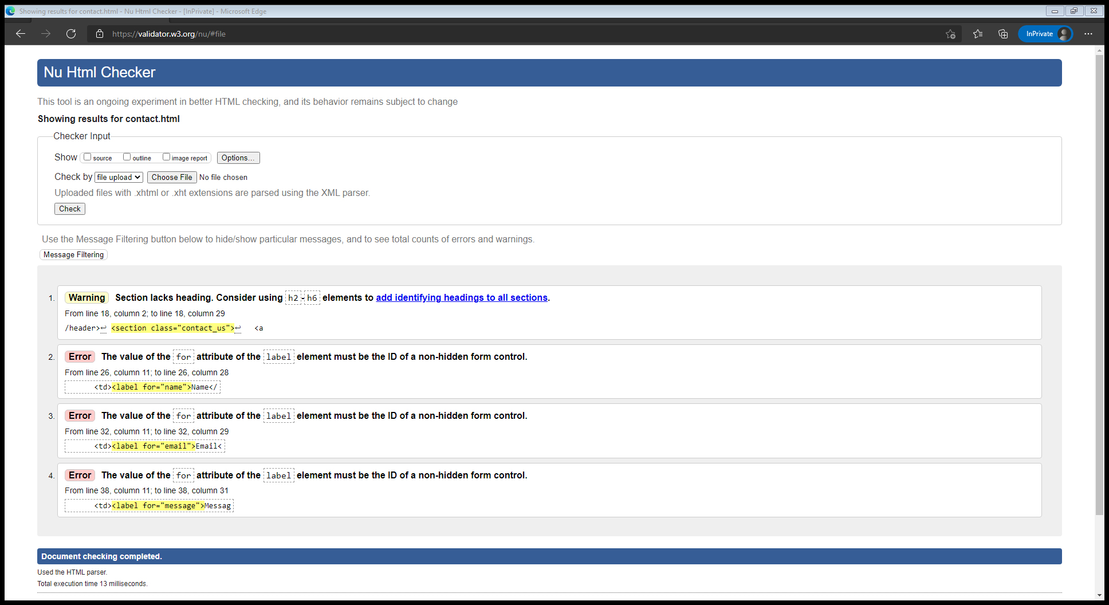

Figure 11 Contact Us

### CSS Validation

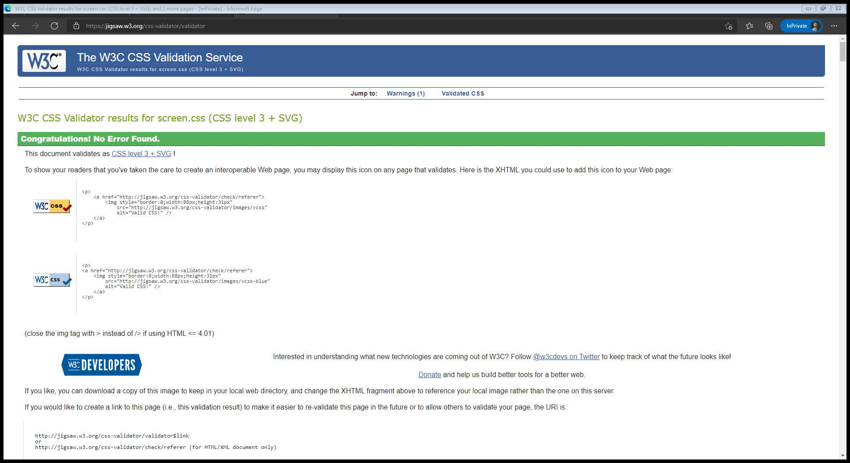

Figure 12 Screen.css validation

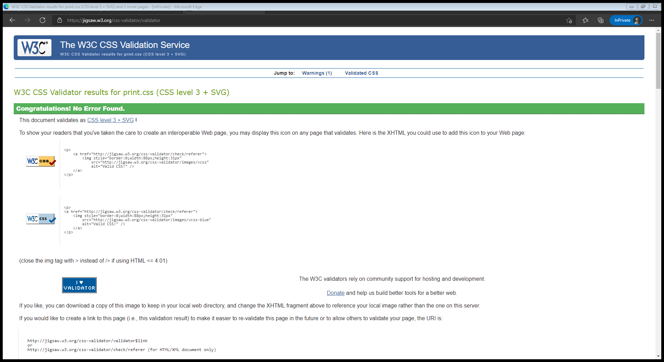

Figure 13 Print.css validation

Print.css file is created to demonstrate the use of browsing printing CSS capabilities to rearrange elements and graphics for better print outs.

# Copyright Permissions

As mentioned, some of the graphics are from google search engine filtered by common creative license which states the validity use of the images for non-commercial projects.

Icons used on the website are from Icons8 website which required attribution link to be included in all pages where the icons are being used. (Added to the footer to make sure it’s included in the whole website).

Pixabay graphics used in the website are free licensed.